18.Design TM using simulator to accept input string ww.

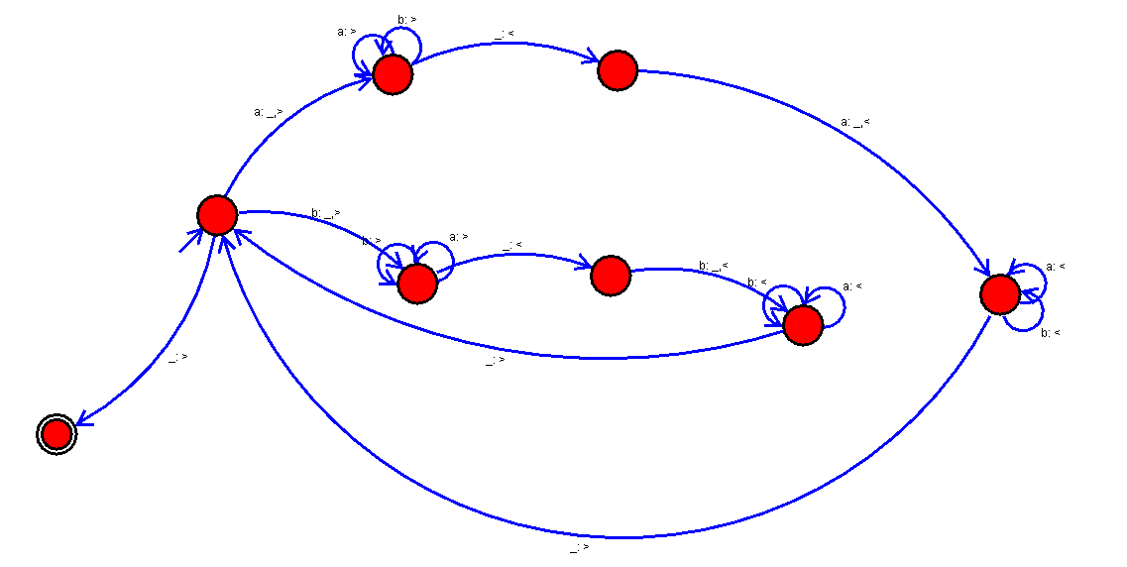

Result: Hence we designed a TM using Simulator to accept input string ww.